SWE20001 – Development Project 1: Tools and Practices

Learning Summary Report

Duy Phuong Nguyen (101204984)

Self-Assessment Details

The following checklists provide an overview of my self-assessment for this unit.

|  |  |  |  |  |
| --- | --- | --- | --- | --- |
|  | Pass (D) | Credit (C) | Distinction (B) | High Distinction (A) |
| Self-Assessment (please tick) |  |  |  | X |

*Self-assessment Statement*

|  |  |
| --- | --- |
|  | Included (please tick) |
| Learning Summary Report | X |
| All Pass Tasks signed off in Doubtfire | X |

*Minimum Pass Checklist*

|  |  |
| --- | --- |
|  | Included (please tick) |
| Pass Tasks done, and Progress on Credit Tasks | X |
| All Pass Tasks signed off in Doubtfire | X |

*Minimum Credit Checklist, in addition to Pass Checklist*

|  |  |
| --- | --- |
|  | Included (please tick) |
| Credit and Pass Tasks done, and Progress on Distinction Tasks. | X |
| One or both of the Final Project reports - meeting Distinction standards | X |
| Final Project meets Distinction criteria | X |

*Minimum Distinction Checklist, in addition to Credit Checklist*

|  |  |
| --- | --- |
|  | Included (please tick) |
| All Tasks (P/C/D/HD) signed off in Doubtfire | X |
| Portfolio consisting of research report (if applicable), and associated pieces | X |
| At least two of the three reports (the Final Project reports + Research report) - meeting High Distinction standards |  |
| Final Project meets High Distinction requirements | X |

*Minimum High Distinction Checklist, in addition to Distinction Checklist*

# Declaration

I declare that this portfolio is my individual work. I have not copied from any other student’s work or from any other source except where due acknowledgment is made explicitly in the text, nor has any part of this submission been written for me by another person.

Signature: Duy Phuong Nguyen

# Introduction

This report summarises what I learnt in SWE20001 Development Project 1. It includes a self-assessment against the criteria described in the unit outline, a justification of the pieces included, details of the coverage of the unit’s intended learning outcomes, and a reflection on my learning.

# Overview of Pieces Included

This section outlines the pieces that I have included in my portfolio…

* Team task:

1. TR3: Team report on week 3.
2. TR6: Team report on week 6.

* Pass task:

1. Task 1.1P: Individual report for week 1 with teamwork contributions evidences.
2. Task 2.1P: Version control using Git.
3. Task 3.1P: Creating a wiki page of group project on GitHub.
4. Task 4.1P: Group meeting to plan and task using Git, GitHub, Toggl, Trello.
5. Task 5.1P: First Iteration of Battleship project, convert CB code to C#.
6. Task 6.1P: Second Iteration using DAD process.
7. Task 7.1P: Continue of Second iteration with stand-up meeting.
8. Task 8.1P: Final iteration with iteration retrospective process.

* Credit task:

1. Task 2.2C: Merge conflict
2. Task 4.2C: How to create good requirement for a project
3. Task 6.2C: Individual report of agile backlog

* Distinction task:

1. Task 7.2D: Unit testing and example of Java Unit testing
2. Task 9.1D: Test Driven Development process
3. Task 10.1D: Individual contribution in Group project presentation.
4. Task 11.1D: Individual contribution to Group project

* High distinction task:

1. Task 11.2HD: Leadership report

# Coverage of the Intended Learning Outcomes

This section outlines how the pieces I have included demonstrate the depth of my understanding in relation to each of the unit’s intended learning outcomes.

## ILO 1:

Explain the lifecycle of a software development project, and describe associated objectives of different activities.

In the lifecycle of a software development project, there are four stages: Planning, Analysis, design, implementation, and maintenance. Maintenance is an important stage, it helps to find errors, get the feedback and back to design and implementation stage again. Done is the last stage where all the completed tasks stay.

The following pieces demonstrate my ability in relation to this ILO:

* Pass Task 1: In this task, I demonstrated the knowledge in lifecycle of a software development project by doing task in the lab which includes 4 steps: To do, doing, feedback and done.
* Pass Task 2: Practicing on problem solving technique, ‘Doing’, ‘feedback’ and ‘done’ section in a lifecycle using Git.
* Pass task 4: Planning stage for the battleship project by create wiki page on GitHub.
* Pass Task 5.1: Practicing on “design” by convert the code, setup coding standard – All sections in software development lifecycle are used
* Pass task 6.1: Using software development lifecycle skill in DAD case.
* Pass task 7.1: Skills in development Lifecycle project are used to complete the battleship project with “implementation” stage.
* Pass task 8.1: Practicing on “Maintenance” stage with iteration retrospective process.
* Distinction task 9.1: Using software development lifecycle skills in TDD problem.
* Distinction task 11.1: : Using software development lifecycle skills in group project.
* High distinction task 11.2: : Using software development lifecycle skills in group project as a leader

## ILO 2:

Apply techniques to analyse, document, extend, and test an existing software solution.

The following pieces demonstrate my ability in relation to this ILO:

* Pass task 3.1: Using GitHub to create wiki page
* Pass task 4.1: Updating Wiki page on GitHub with new documents
* Pass task 5.1: Using Visual studio to analyse code, identify bugs.
* Distinction task 7.2: Using Unit Test on Java.
* Distinction task 9.1: Using TDD process for document, testing in our D/HD project
* High Distinction task 11.2: Including document for D/HD leadership report

## ILO 3:

Utilise contemporary software development tools for version control, issue tracking, documenting software designs, and unit testing; and explain their role in a software development project.

The following pieces demonstrate my ability in relation to this ILO:

* Pass task 2.1: Using GitHub, GitBash for task checking, code merging
* Pass task: 3.1: Using GitHub as a platform for wiki page
* Pass task 4.1: Using GitHub to upload document
* Pass task 5.1: Using Visual studio for converting code, checking bugs
* Pass task 6.1: Using trello and toggl for task tracking
* Pass task 7.1: Using trello for task tracking, Using visual studio for coding
* Distinction task 7.2: Using Java for Unit Testing.
* Distinction task 11.1: Using Trello for task tracking, Discord for team communication, task merging for group D/HD project.

## ILO 4:

Apply and use tools and techniques to work effectively as a member of a software development team, and reflect upon group work experience.

The following pieces demonstrate my ability in relation to this ILO:

* Pass task 1.1: Using slack for team communication
* Pass task 4.1: Using Trello for managing and task setting.
* Distinction task 8.1: Practice TDD process with the help of Discord for discussing and Trello for task managing and task setting
* Distinction task 11.1: Using Trello for managing and task setting. Using Discord for task splitting, voice communication. Scrum process to develop project.
* High Distinction Task 11.2HD: Leadership Report – Using Discord as communication tools for team during HD project

# Reflection

## The most important things I learnt:

I have skills for team working, development a project using different process, different useful tools. I also learnt how to manage task, tracking task and merging works to avoid conflict. I understand how to be good in working as a team with communication skills, documenting skill, lifecycle of software development project. Now I can apply Agile development in other software project.

## The things that helped me most were:

Lecture: lecture provides me a lot of useful information with definitions, demonstration to help me understand how to develop a project.

Lab task: Helps me to improve software development skills: software, keyword and process which are currently used in software industry.

Trello: Great tool to managing and tracking task.

Slack: Slack is a really good tool for communication with we can’t do voice chat on this flatform. This is a disadvantage because we cannot meet face-to-face to discuss about our task, project during COVID-19.

GitHub: Perfect tool for software development project, We can preview work, merging, approve and control work of all the member.

## I found the following topics particularly challenging:

Continuous Iteration is the most challenging task in this project. I can’t find a lot of information, definition about it in Lecture slide and on Google.

## I found the following topics particularly interesting:

The most interesting topic for me is Unit Testing and TDD process. I have a change to practice it during the D/HD project and also learn about Java language which is a new coding language for me.

## I feel I learnt these topics, concepts, and/or tools really well:

Four unit learning outcome is learnt well during the whole semester with all completed tasks and evidence which were submitted to Doubtfire

Agile development models: This Unit helps me to understand how software company can handle and deploy such a big program without bugs, errors in a short period of time

## I still need to work on the following areas:

Continuous Iteration is a really hard topic as I mentioned above. I tried to applied it to our group project however it is just a basic level and I have to practice more on that to fully understand the concept of Continuous Iteration

## My progress in this unit was …:

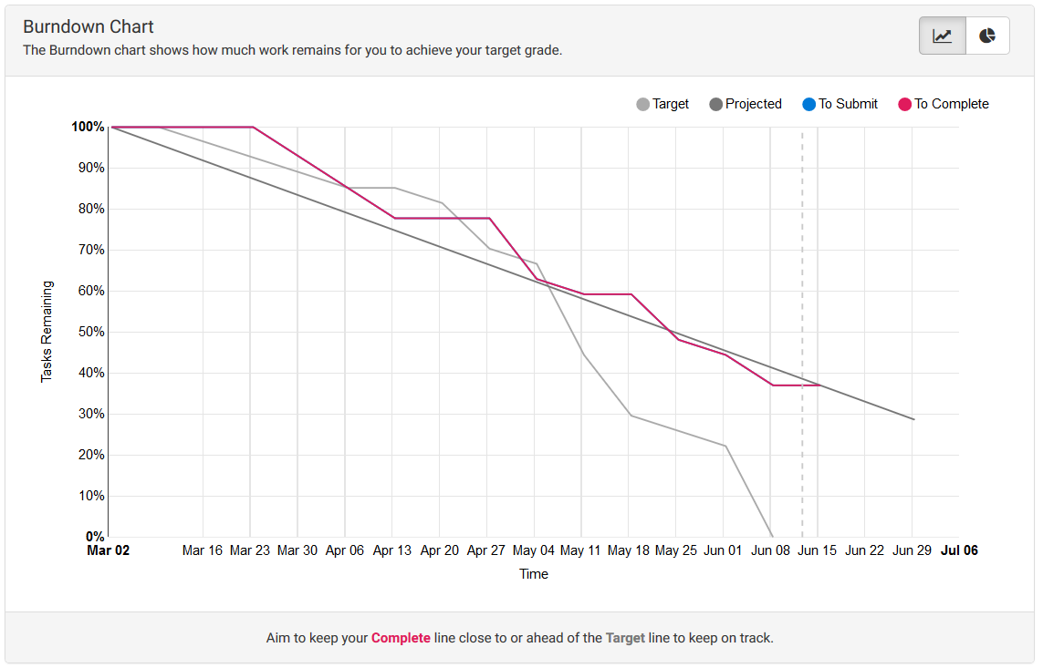

This graph shows how I engage with this unit. I tried to finish all the task on target date. At the end of the semester, I have to follow another subject to the graph is worst at the end. However, I’m aiming for HD so I trying to finish all the task before due date

## This unit will help me in the future:

This Unit provides me a lot of knowledge, tools, and experience to apply in my future carer. Lab works provide me chances to practice and apply all the knowledge I got from lecture to a real project so I can be confident, experienced in another project in the future.

## If I did this unit again I would do the following things differently:

I will try to be a team leader so I can practice leadership, managing all of my team member and also improved my D/HD project quality.

I also want to recruit more members for my group. 3 people are not enough for D/HD project, the workload is huge and one of my teammate (product owner) is not helpful at all so the quality of our group project is just acceptable.